Fundamentals of Programing

Lab Task # 08

Lab Instructor: Muhammad Affan

Name: Syed Imran Khalil

CMS ID: 479900

Date: 11/29/2023

Task 1:

Write a C++ program to calculate average of numbers of array

Code:

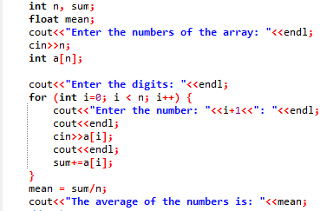

Output:

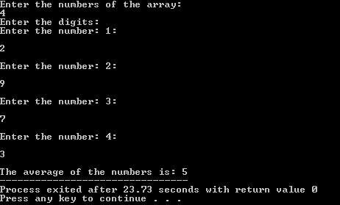

Task 2:

Implement Bubble sort on an array of 5 integers.

Code:

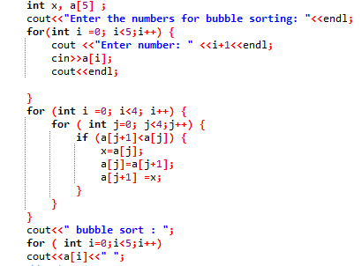

Output:

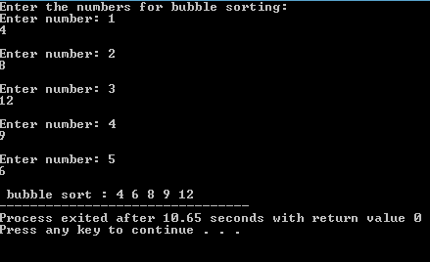

Task 3:

Code:

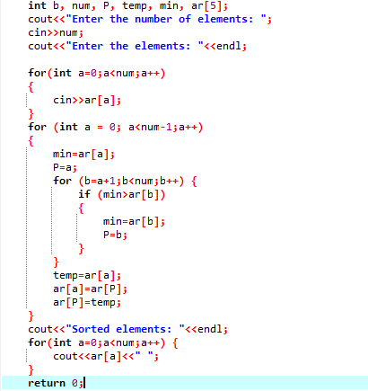

Output:

